Task 8 --

A Virtual Private Network (VPN) creates a secure, encrypted connection over a less secure network, like the internet. Think of it as building a private, protected tunnel through the public internet. This tunnel ensures your online activities remain private and secure.

Here's a breakdown of how a VPN works:

**1. Connecting to the VPN Server:**

* When you use a VPN app on your device (computer, smartphone, tablet), it doesn't connect directly to the website or online service you want to access.
* Instead, your device first establishes a connection with a remote VPN server, which is owned and operated by your VPN provider.
* This connection is often initiated through a login process where you provide authentication credentials.

**2. Data Encryption:**

* Once connected to the VPN server, your VPN client software immediately encrypts all outgoing internet data from your device. This means your information (Browse history, passwords, financial data, etc.) is scrambled into an unreadable code.
* VPNs use advanced encryption protocols (like AES 256-bit encryption, which is also used by banks and the military) and cryptographic keys to make this data virtually impossible to decipher by anyone without the correct key.

**3. Secure Tunneling and Encapsulation:**

* The encrypted data is then "encapsulated," meaning it's wrapped inside additional data packets. This further conceals its original purpose and makes it harder to analyze or trace.
* This encapsulated, encrypted data travels through a secure "tunnel" to the VPN server. This tunnel is the core of the VPN's security, shielding your data from surveillance or interception by hackers, your Internet Service Provider (ISP), or other third parties.

**4. IP Address Masking:**

* When your encrypted data reaches the VPN server, the server decrypts it.
* Crucially, the VPN server then assigns a **new, virtual IP address** to your data. This new IP address belongs to the VPN server itself, which can be located in a different city or even a different country than your actual location.
* This process effectively masks your real IP address and physical location from the websites and services you visit.

**5. Forwarding and Decryption (Return Path):**

* The VPN server then forwards the decrypted data (with its own IP address) to its intended destination (e.g., the website you want to visit).
* When the website sends data back to you, the VPN server receives it, encrypts it again, encapsulates it, and sends it back through the secure tunnel to your device.
* Your VPN client on your device then decrypts the data, allowing you to access the content.

**Key Benefits of Using a VPN:**

* **Enhanced Privacy:** Your ISP, government agencies, and other third parties cannot see your Browse history, the websites you visit, or the data you send and receive.
* **Increased Anonymity:** By masking your real IP address, a VPN makes it difficult for websites and online services to track your online activities back to you.
* **Data Security:** Your data is protected by strong encryption, especially when using unsecured public Wi-Fi networks, guarding against hackers and cybercriminals.
* **Bypassing Geo-restrictions and Censorship:** By connecting to a VPN server in a different country, you can appear to be Browse from that location, allowing you to access geo-blocked content (like streaming services) or bypass internet censorship in certain regions.
* **Avoiding Bandwidth Throttling:** Some ISPs might intentionally slow down your internet speed for certain activities (like streaming). A VPN can help you bypass this by encrypting your traffic, making it harder for your ISP to identify and throttle specific types of data.

In essence, a VPN acts as an intermediary, rerouting your internet traffic through a secure, encrypted server. This process provides a powerful layer of privacy, security, and freedom in your online experience.

**OpenVPN** is an open-source VPN protocol that uses SSL/TLS for secure key exchange. It can operate over UDP or TCP, which makes it flexible for different network environments. OpenVPN uses certificates for authentication, which provides strong security when properly managed. The data channel is encrypted using symmetric ciphers like AES-256. Because it runs in user space, it is highly configurable and supports features like perfect forward secrecy (PFS), which ensures that even if a key is compromised, past sessions remain secure. From a testing perspective, you would verify certificate validity, check for weak cipher suites, and ensure no data leaks occur outside the tunnel.

**IKEv2/IPsec** combines the Internet Key Exchange version 2 protocol with IPsec for encryption and authentication. IKEv2 handles the negotiation of security associations and keys, while IPsec encrypts the data. This protocol is known for its stability and fast reconnection, especially useful for mobile users switching networks. It uses strong encryption algorithms and supports PFS. Testing IKEv2/IPsec involves checking the robustness of key exchange, verifying that the implementation resists replay and man-in-the-middle attacks, and ensuring that the VPN does not leak traffic during reconnections.

**WireGuard** is a newer VPN protocol designed for simplicity, speed, and modern cryptography. It uses state-of-the-art cryptographic primitives like Curve25519 for key exchange and ChaCha20 for encryption. WireGuard’s codebase is much smaller than traditional VPNs, reducing the attack surface. It operates at the kernel level for performance. Testing WireGuard includes verifying key management, ensuring no IP or DNS leaks, and checking for proper handling of peer authentication.

In all cases, encryption is critical. Symmetric encryption algorithms like AES-256 or ChaCha20 ensure data confidentiality, while hashing algorithms and message authentication codes (MACs) ensure data integrity and authenticity. Proper key management and secure random number generation are essential to prevent cryptographic weaknesses.

To start testing a VPN’s security, you can use a combination of tools and techniques tailored to the VPN protocol and environment. For example, to check for encryption strength and protocol support, tools like **OpenVPN’s built-in diagnostics**, **IKE-scan** for IPsec/IKE, or **WireGuard’s utilities** can help verify configurations and supported cryptographic parameters.

For traffic analysis, capturing packets with **Wireshark** while connected to the VPN allows you to inspect whether traffic is fully encrypted and if any DNS or IP leaks occur. You can also use specialized leak testing tools or websites that detect if your real IP or DNS requests are exposed outside the VPN tunnel.

To test authentication robustness, you might attempt brute force or credential guessing attacks if authorized, or check for weak certificate validation by trying to use invalid or expired certificates. Vulnerability scanning tools like **Nessus**, **OpenVAS**, or **Nmap** scripts can identify known vulnerabilities in VPN server software.

**VPN limitation : -**

While Virtual Private Networks (VPNs) offer significant advantages in terms of privacy, security, and access, it's crucial to understand their limitations. A VPN isn't a silver bullet for all online threats, and being aware of its drawbacks helps you use it more effectively and manage your online expectations.

Here are some key limitations of VPNs:

1. **Reduced Internet Speed:**
   * **Encryption Overhead:** The process of encrypting and decrypting data, and routing it through a remote server, adds computational overhead and latency. This can slow down your internet connection, especially for bandwidth-intensive activities like streaming high-definition video, online gaming, or large file downloads.
   * **Server Distance and Congestion:** The farther you are from the VPN server, the more latency you'll experience. Also, if a server is overloaded with too many users, speeds can suffer.
2. **Not a Complete Security Solution:**
   * **No Protection Against Malware and Viruses:** A VPN encrypts your connection, but it doesn't scan for or block malware, ransomware, or viruses. If you download an infected file, click a malicious link, or fall for a phishing scam, a VPN won't prevent the infection or compromise. You still need antivirus software and good cybersecurity hygiene.
   * **No Protection Against Phishing Attacks:** VPNs don't detect or block phishing attempts. If you're tricked into entering your credentials on a fake website, even with a VPN, your data will still be sent to the attacker.
   * **Does Not Prevent Tracking by Cookies and Web Trackers:** While a VPN masks your IP address, it doesn't stop websites from using cookies, browser fingerprinting, or other tracking technologies to monitor your online behavior.
   * **Doesn't Protect Against User Error:** If you willingly share personal information on social media or insecure websites, a VPN cannot hide that information.
3. **Dependency on the VPN Provider's Trustworthiness:**
   * **Logging Policies:** Your privacy is largely dependent on the VPN provider's "no-logs" policy. Some less reputable VPNs (especially free ones) may log your online activities, which defeats the purpose of using a VPN. They might even sell this data to third parties. It's crucial to choose a VPN provider with a transparent and audited no-logs policy.
   * **Security Vulnerabilities:** A VPN server itself can be a target for cyberattacks. If a VPN provider uses weak encryption protocols, has outdated software, or experiences a data breach, your data could be exposed.
4. **Cost (for reputable services):**
   * While free VPNs exist, they often come with significant limitations (slow speeds, data caps, intrusive ads, less secure protocols, and sometimes, questionable logging practices). Quality VPN services that offer strong security, reliable performance, and a strict no-logs policy typically come with a subscription fee.
5. **Blocked Access to Certain Services:**
   * **Streaming Services:** Many streaming platforms (like Netflix, Hulu, etc.) actively try to detect and block VPN traffic to enforce geo-restrictions. While some VPNs are better at bypassing these blocks, it's an ongoing cat-and-mouse game.
   * **Other Websites/Services:** Some websites, online banking portals, or gaming services may also block known VPN IP addresses to prevent fraud, maintain regional licensing, or for security reasons.
6. **Legal and Regulatory Implications:**
   * **Legality in Certain Countries:** While VPNs are legal in most countries, some nations (like China, Russia, Iran, and the UAE) have strict regulations or outright bans on VPN usage. Using a VPN in these regions could lead to fines or legal consequences.
   * **Illegal Activities:** A VPN does not make illegal activities legal. If you engage in illegal activities while using a VPN, you are still breaking the law, and law enforcement agencies may still be able to trace your activity with sufficient effort and resources.
7. **Battery and Data Consumption:**
   * Running a VPN client on mobile devices can consume more battery due to the continuous encryption/decryption process.
   * The encryption overhead can also slightly increase your data consumption, which might be a concern if you have limited data plans.
8. **Connection Stability (Potential for Drops):**
   * Even with reputable VPNs, connections can sometimes drop. If a VPN connection drops without a "kill switch" feature enabled, your real IP address and unencrypted traffic could be temporarily exposed.

Installed free vpn windscribe

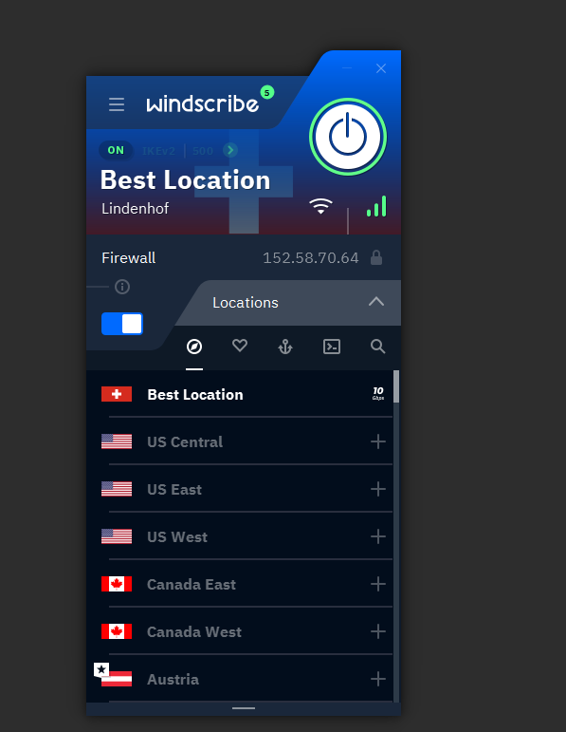

Current with vpn ip address are different server / after disconnect

